1. There are many online utilities that allow us to perform such verification and gain info about time, certificate and certificate chains.
2. Let’s see one such service.   
   <https://www.geocerts.com/ssl-checker>
3. 
4. 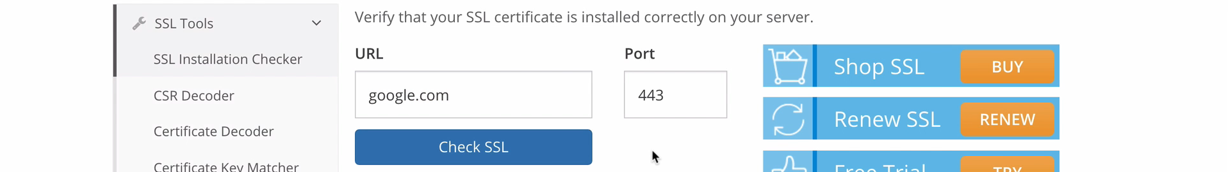 Output: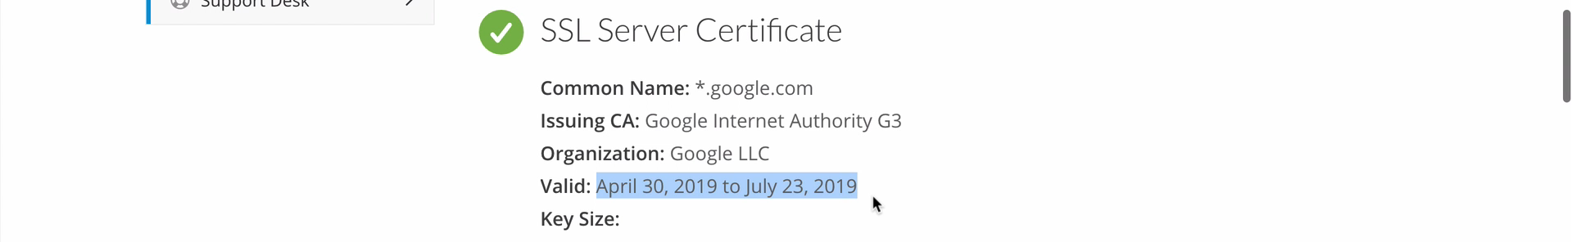  
     
   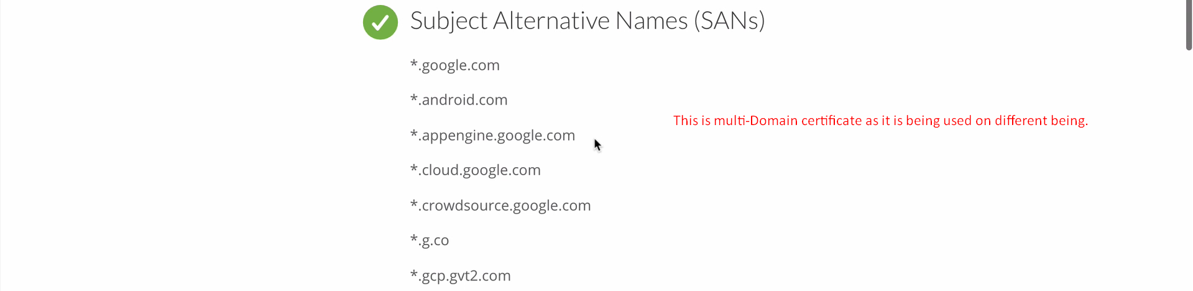  
     
   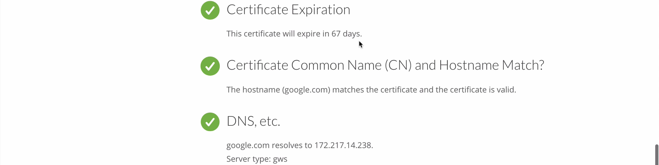
5. 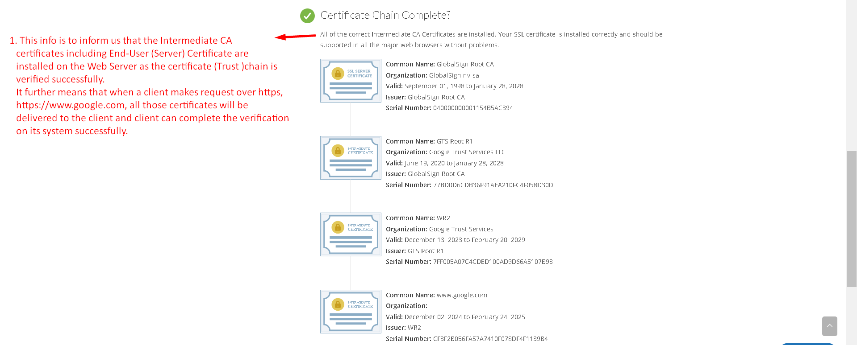
6. Let’s try another website.  
   <https://www.ssllabs.com/ssltest/?ref=blog.grizzlycyber.com>
7. Here a lot of other info like
   1. Which SSL and TLS versions are supported by this certificate.
   2. Which Cipher Suits are supported for which SSL/TLS version.
8. Google Report:  
   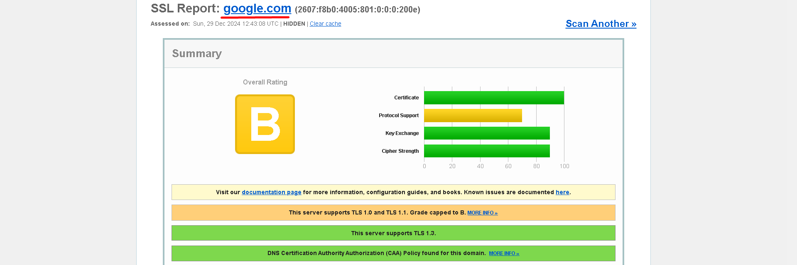  
     
   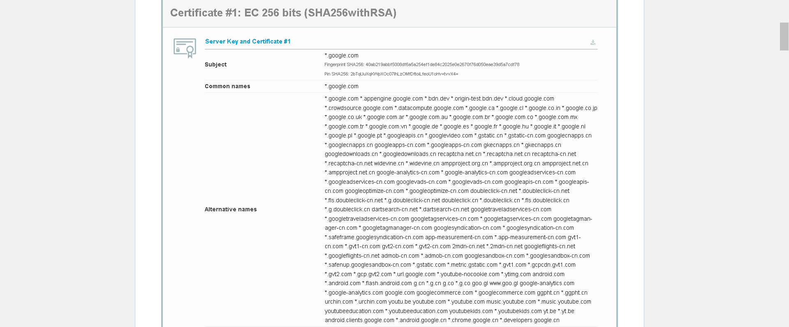  
     
   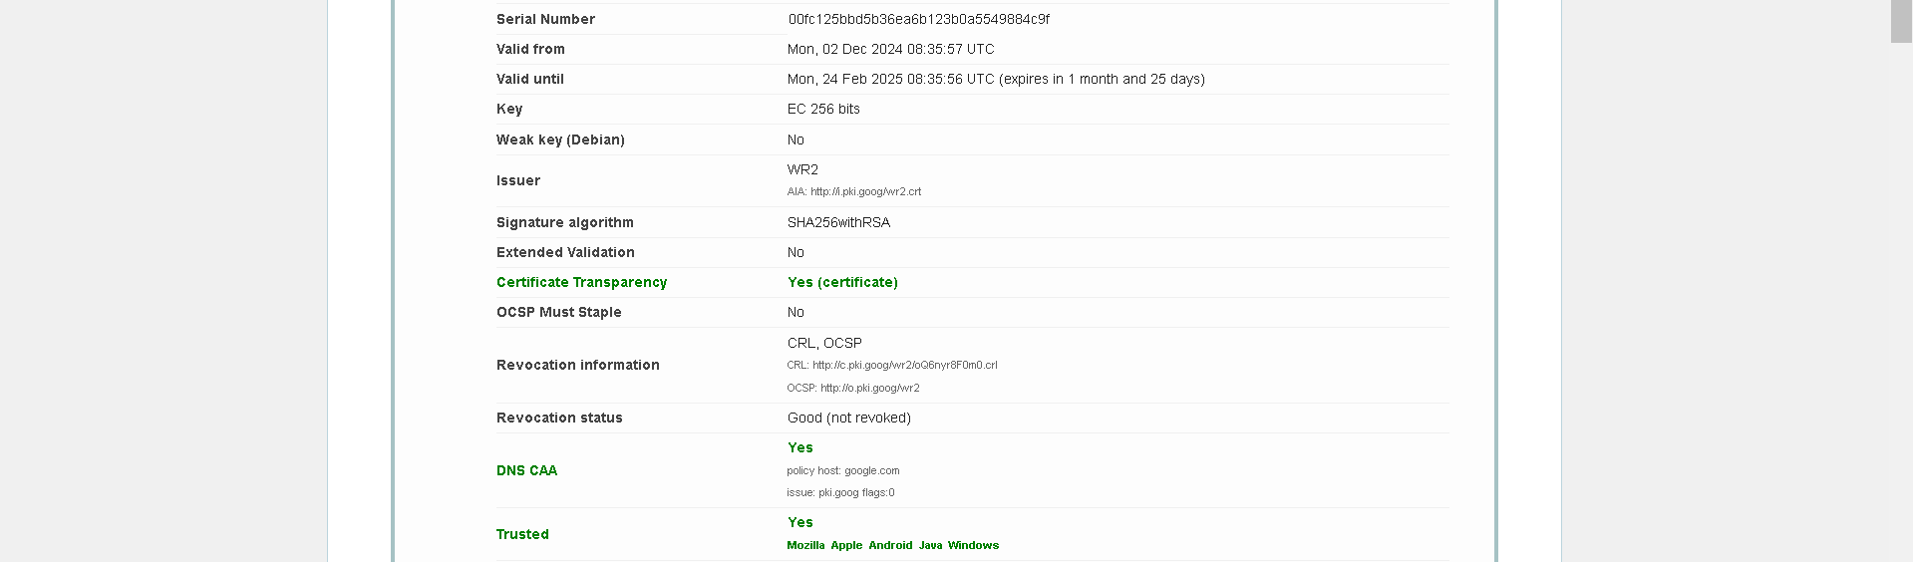  
     
   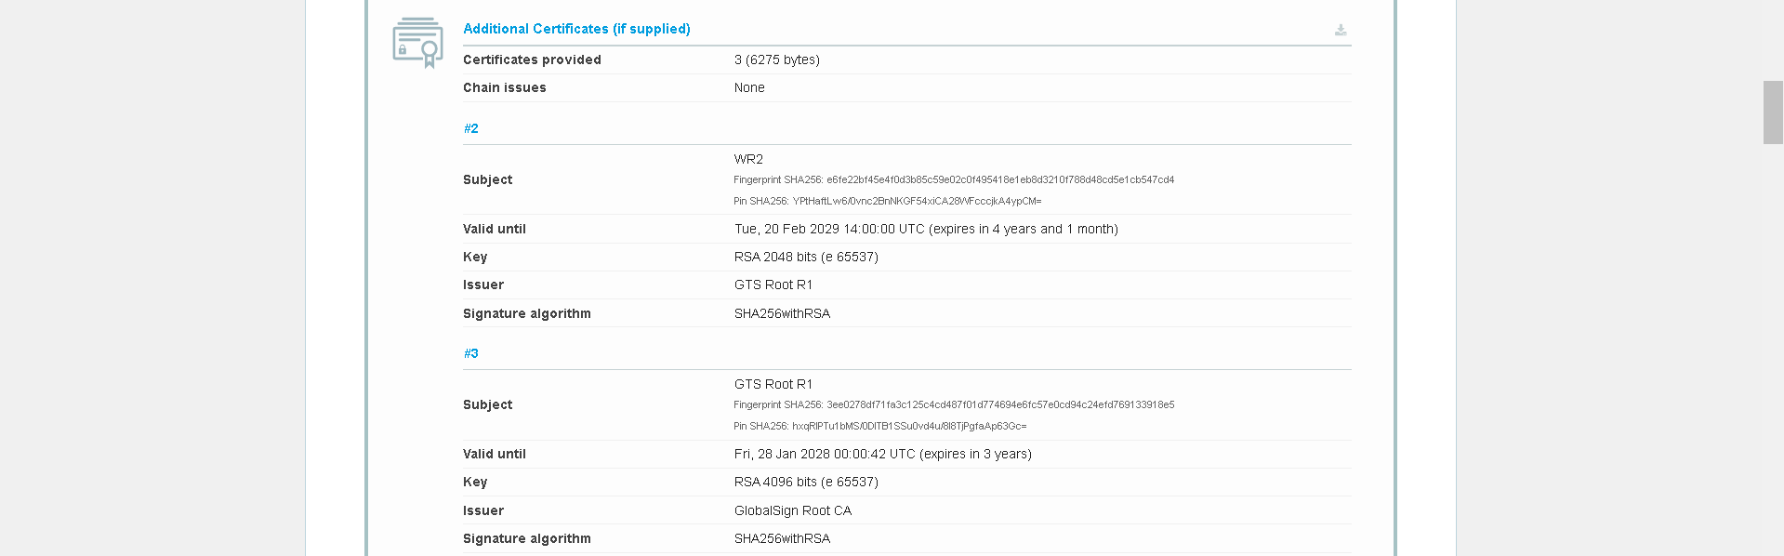  
     
   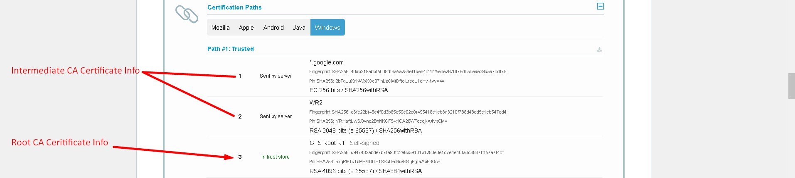  
     
     
     
     
     
   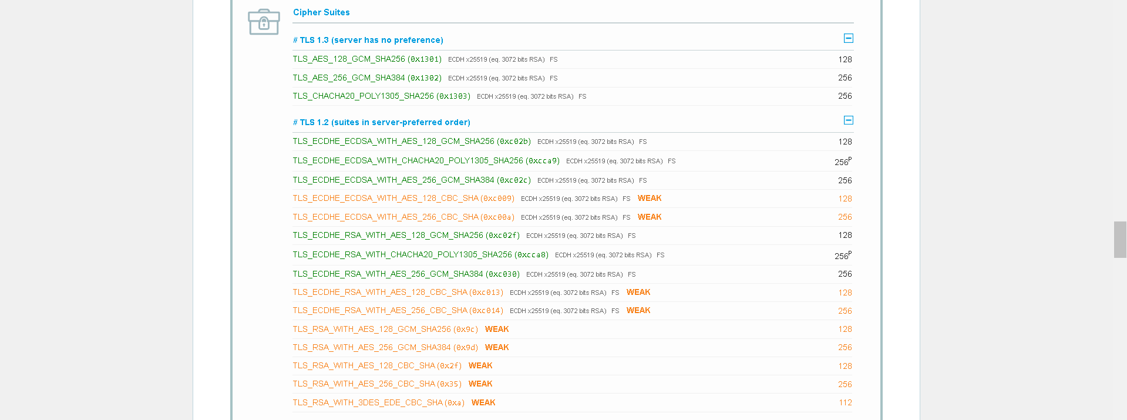  
     
   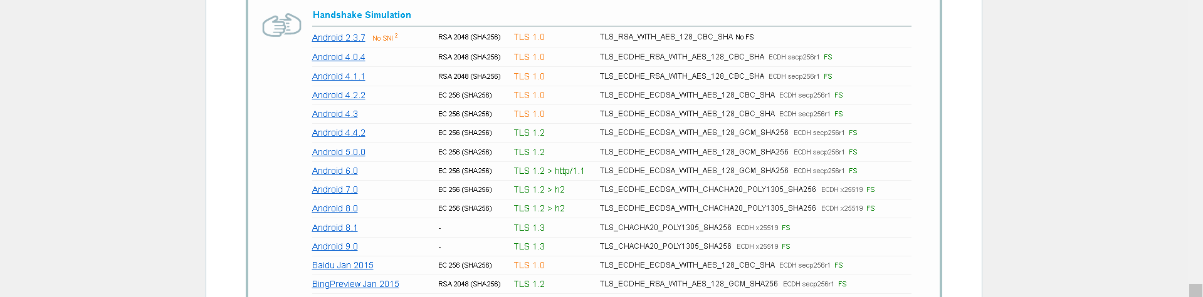Don’t worry we will talk about many of these things in respective lectures.